Predict Allsvenskan – Bayesian modeling of football results

# Introduction/ Project description

A very popular part of the sports industry is to predict future outcomes. In football the predictions often concerns which team that will win next game, how many goals will each team score and which team will have the most points at the end of the season.

One rather popular model the recent years for modeling football data is the hierarchical Bayesian model. It is used for estimating the strength of the teams and to predict the score in a football game.

The results of a game is a noisy measurement of team strength. Want a model that makes it easy to quantify out uncertainty about the underlying strengths.

This can be achieved by a Bayesian hierarchical model.

qualities

# Earlier studies

There are several different studies where a hierarchical Bayesian model has been used for modeling football outcomes.

# Data

The dataset consists of results in the Swedish top division in football, Allsvenskan, for the full 2015 season and the twelve first rounds of the 2016 season. For the remaining rounds in the 2016 season there are no results but these fixtures are also included in the dataset and will be predicted with the model.

# The model

Much of the inspiration for the model is taken from…

The number of goals in a football game is Poisson distributed

The number of goals for the home team and the away team is specified in the following way

Where the priors for the parameters are set as following

DAG representation of the model:

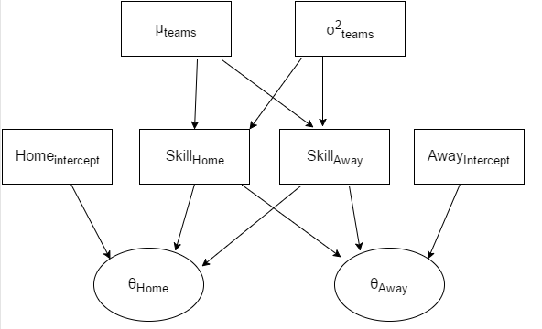

# Software

# Results